**Report on Industrial visit to Parag Dairy on 1st June 2022**

Department of Bioengineering firmly believes that industrial visit helps to bridge the gap between the classroom and the real working world. The objective of this visit was to provide real-life exposure to Bioengineering students about industrial organizations and their mode of operations.

Keeping this view in point, on the occasion of World Milk Day an industrial visit to Parag Co-operative Pvt. Ltd. situated in Chak Ganjaria, Sultanpur road was organized by the Department of Bioengineering, Integral University, Lucknow on 1st June 2022.

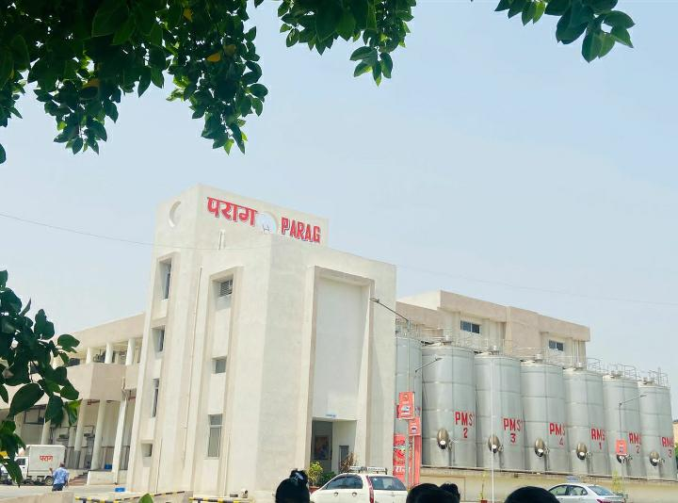

Parag is one of the oldest Dairy in India, established in the year 1938. The new plant located at Sultanpur road was launched in the year 2021. The plant consists of 4 silos having a capacity of 60,000 litres each. They procure milk from 15 nearby districts and provide bulk milk coolers to prevent the spoilage of milk. Marketing Director, Prashant Arya provided insights about the milk procurement system, pasteurization, homogenization, quality assurance, and different production units of Parag milk and milk products.

The students were accompanied by faculty members Er. Poonam Sharma, Dr. Rahul Singh, Miss Sufia Aziz Siddiqui, and Miss Ghazala Anjum of the Department of Bioengineering.

The plant consisted of the following units:

1. CIP (Cleaning In Place)
2. Quality Assurance Lab
3. Milk and milk product storage rooms
4. Milk products manufacturing units (Paneer, Ghee, Butter, Khoa, Chenna kheer)
5. Packaging unit

